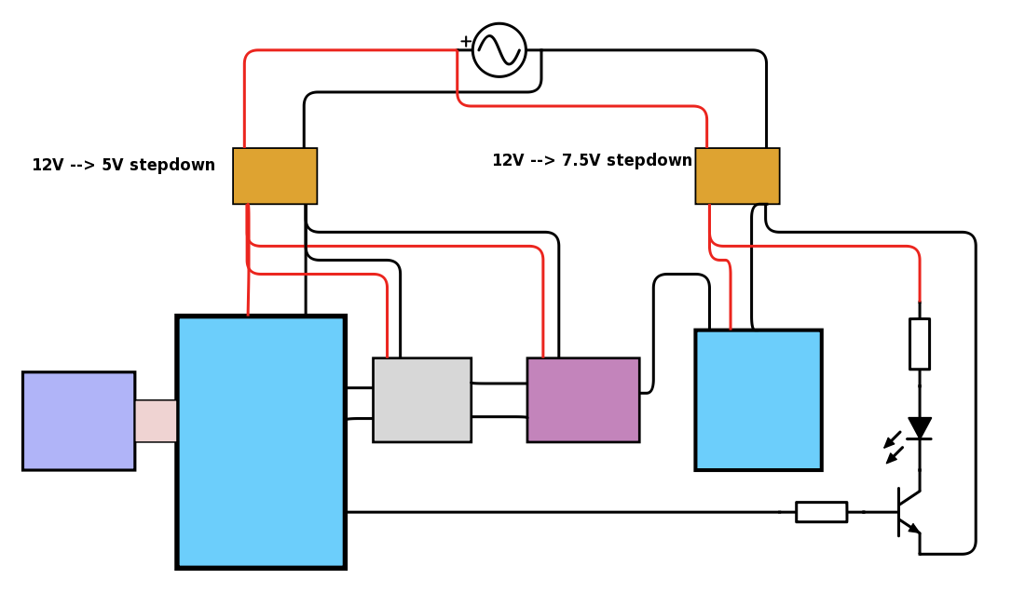

iRoger – electrical circuit

Raspberry Pi 0

Pi Camera Noir

Logic converter  
5V <- -> 3V

Tri-state  
buffer

Dynamixel XL 320

data  
(TTL)

UART

NPN

<

>

<

>

<

>

GPIO 18

GPIO 25

+5V

GND

R1

R2